**Submissions:**

1. All design documents
2. All Java codes
3. SQL code and database file
4. 4. Screenshots (or screen video captures) showing the test of each use cases.

**Story 1:**

As a user, I want to add a new product into the system.

Common use case:

1. Product added successfully.

Exception case:

1. ProductID cannot be empty.

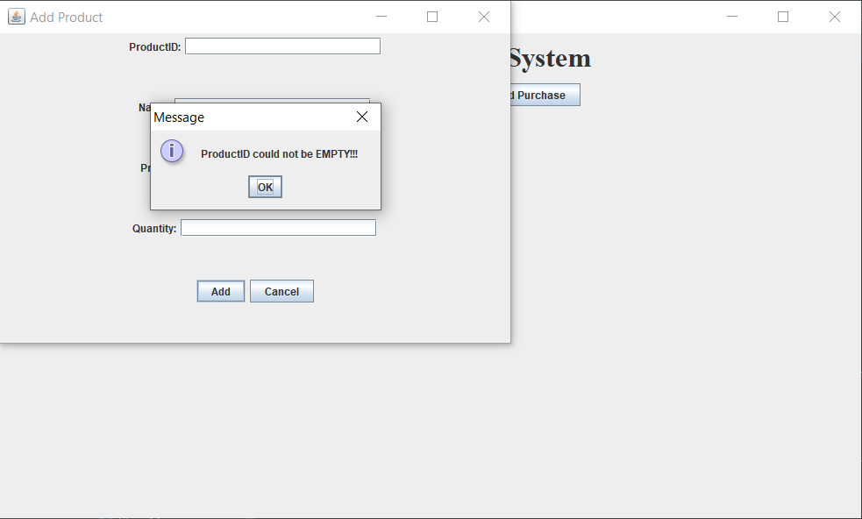

1. ProductID is not a number.

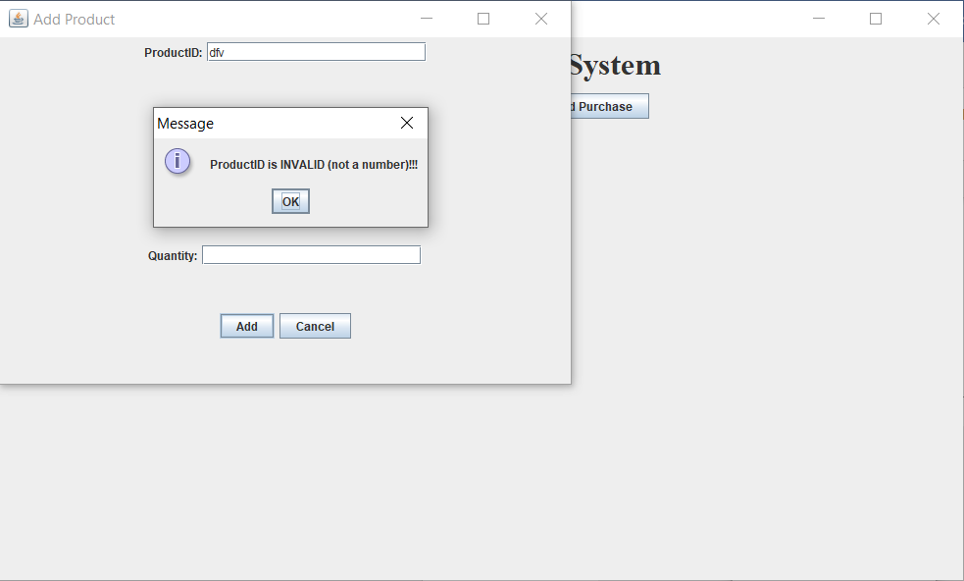

1. Product name not empty.

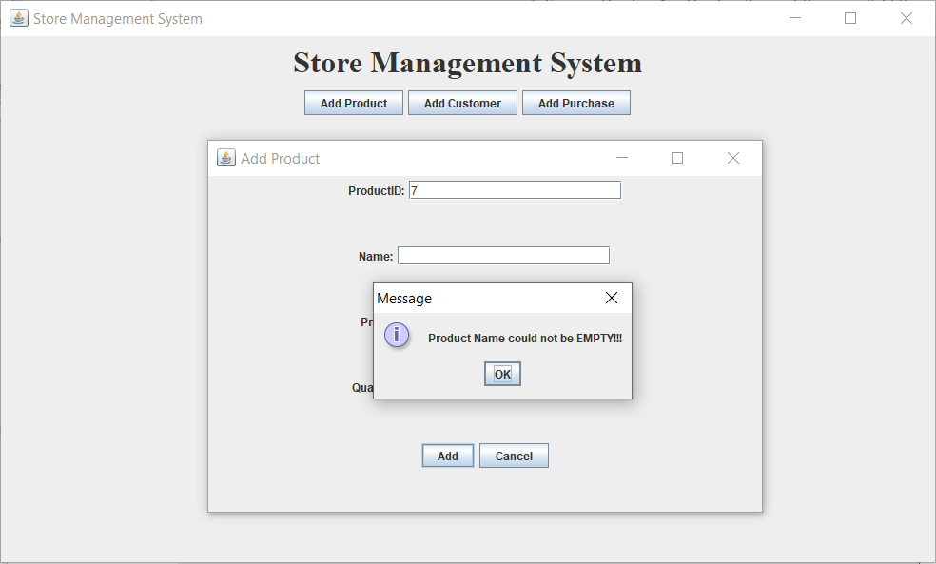

1. Price is invalid.

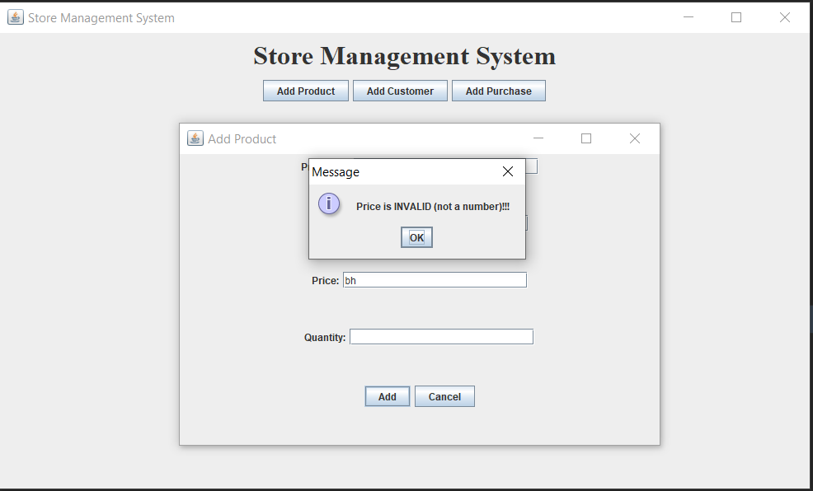

1. Quantity is invalid.

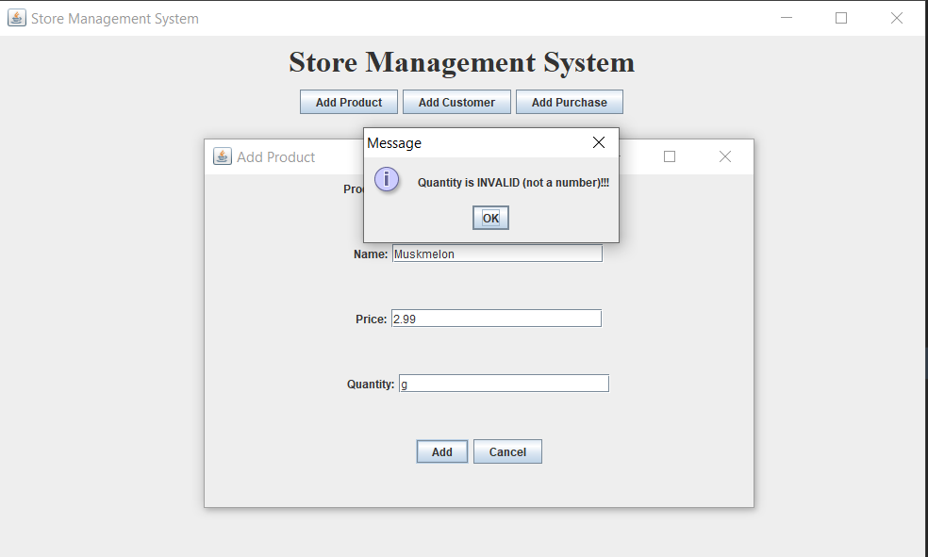

UI windows:

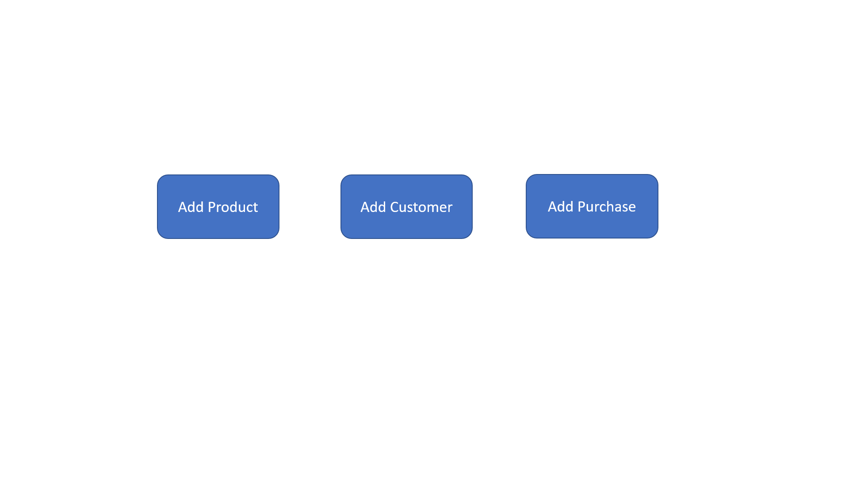

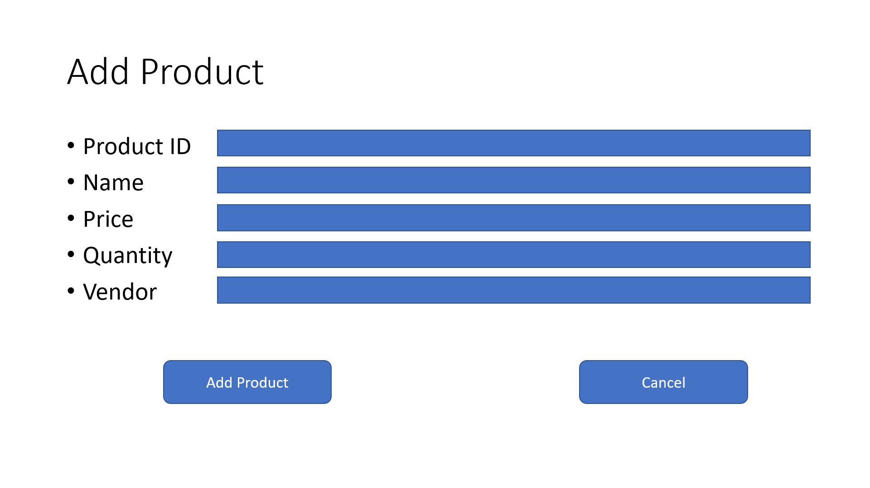

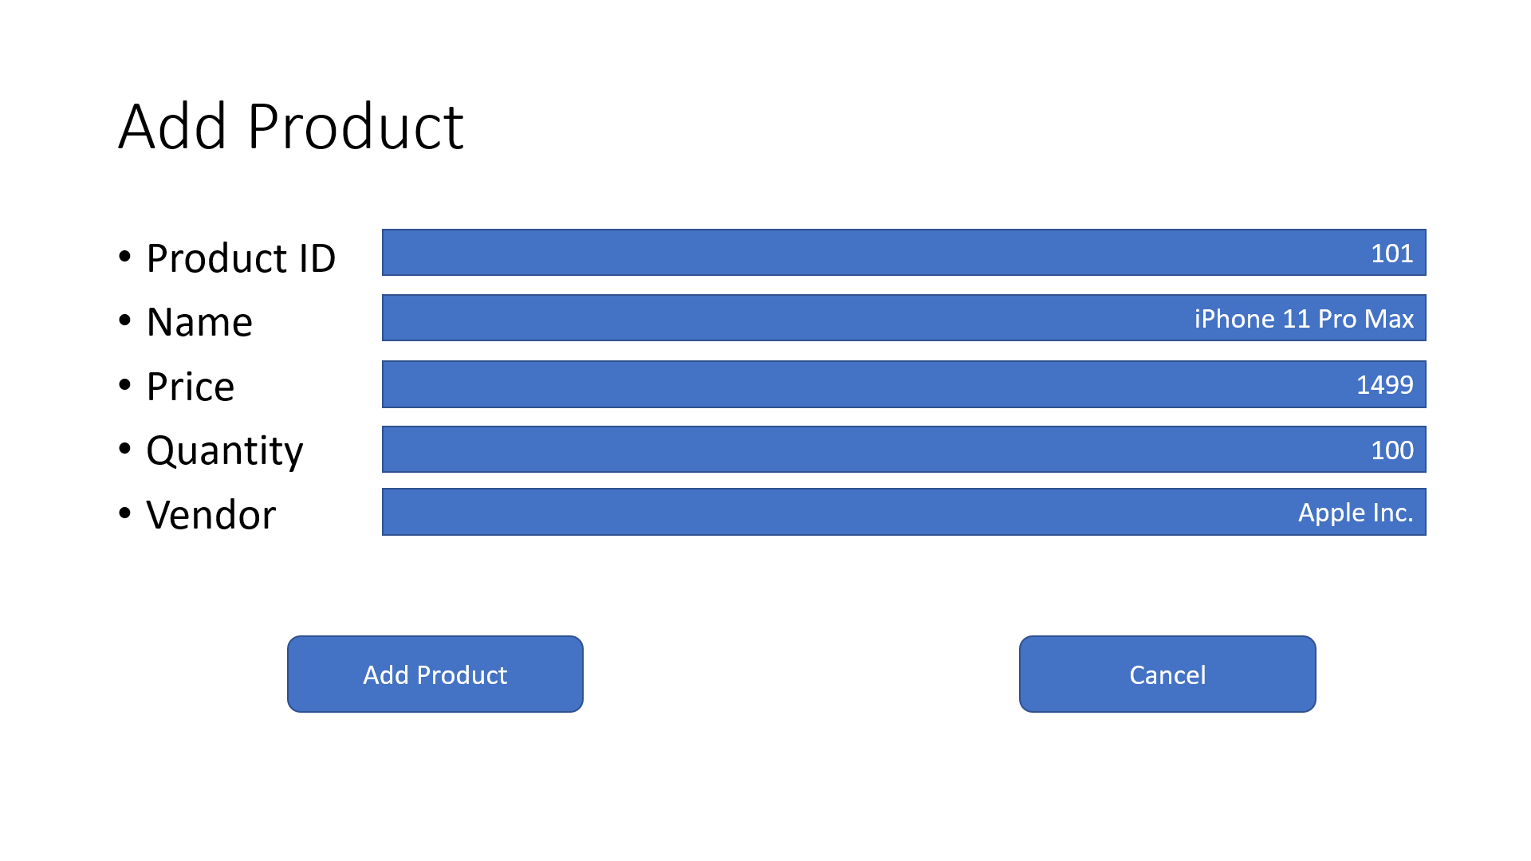

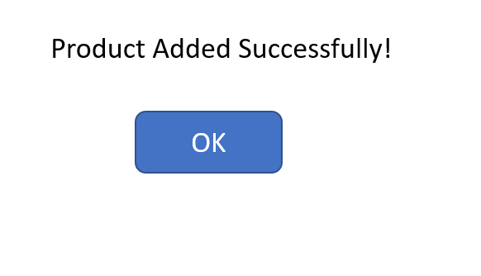

SQL Create query:

CREATE TABLE "Products" (

"ProductID" INTEGER NOT NULL PRIMARY KEY AUTOINCREMENT,

"Name" TEXT,

"Price" REAL NOT NULL,

"Quantity" INTEGER NOT NULL,

"TaxRate" REAL DEFAULT 0.09,

"Vendor" TEXT

)

SQL Insert query:

INSERT INTO Products (ProductID, Name, Price, Quantity) VALUES

(1, ‘Apple’, 0.99, 100),

(2, ‘Pear’, 0.99, 100),

(3, ‘Peach’, 0.99, 100),

(4, ‘Banana’, 0.49, 200),

(5, ‘Pineapple’, 2.49, 50);

**Story 2:**

As a user, I want to add a new customer into the system.

Common use case:

1. Customer added successfully.

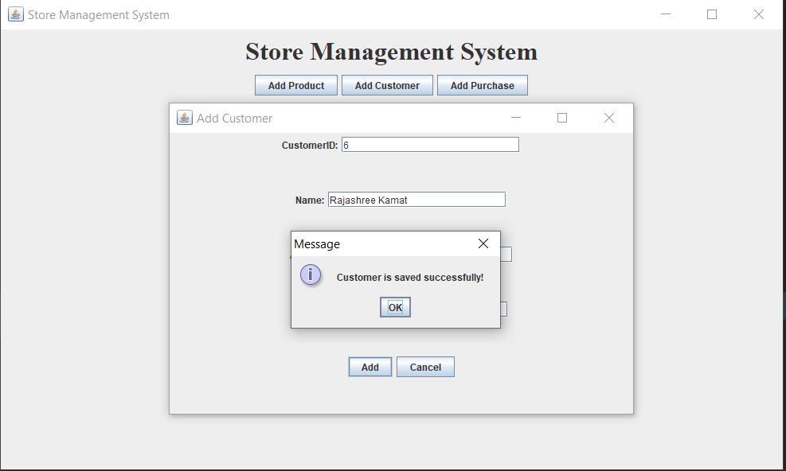

Exception case:

1. CustomerID cannot be empty.

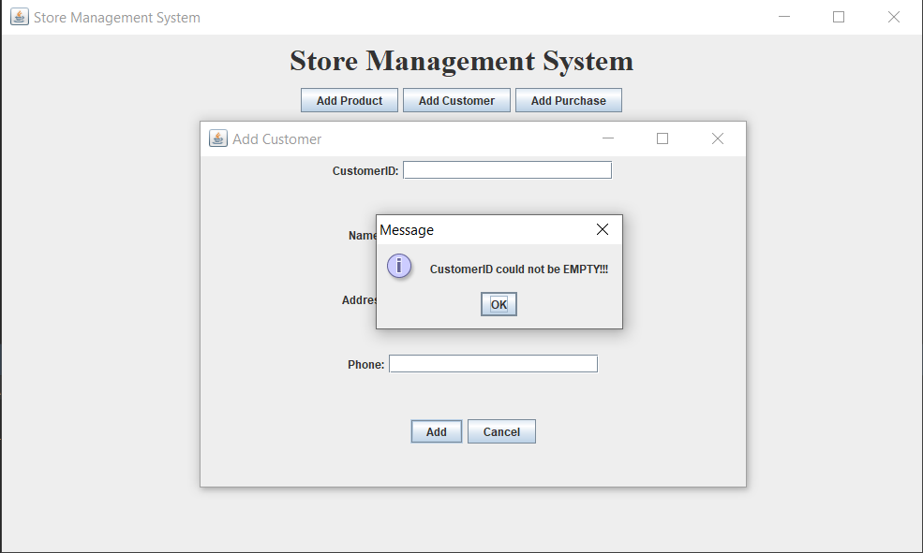

1. CustomerID is not a number.

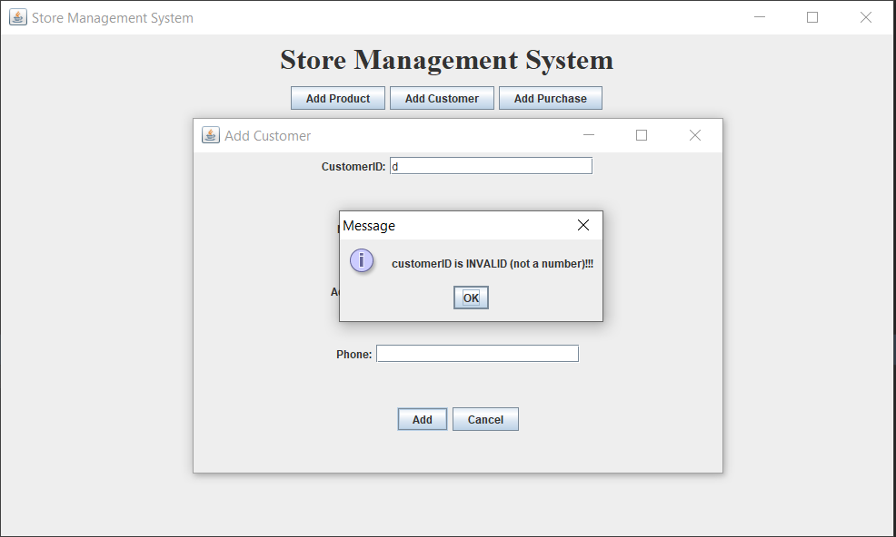

1. Customer Name cannot be empty.

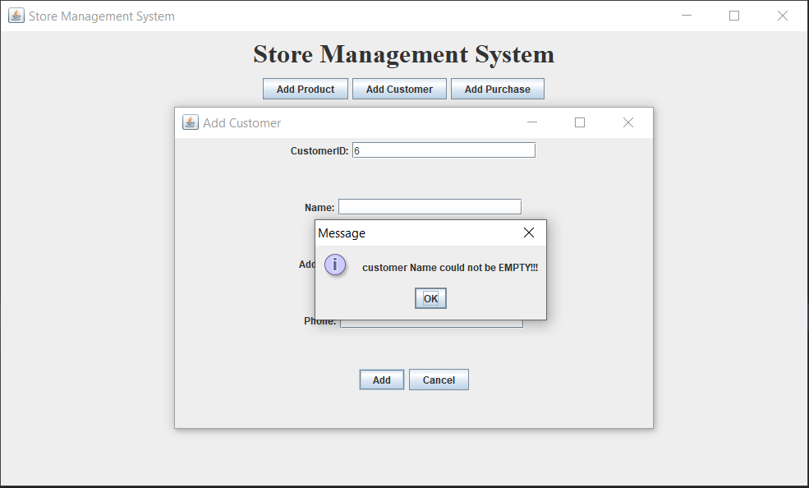

1. Address is invalid.

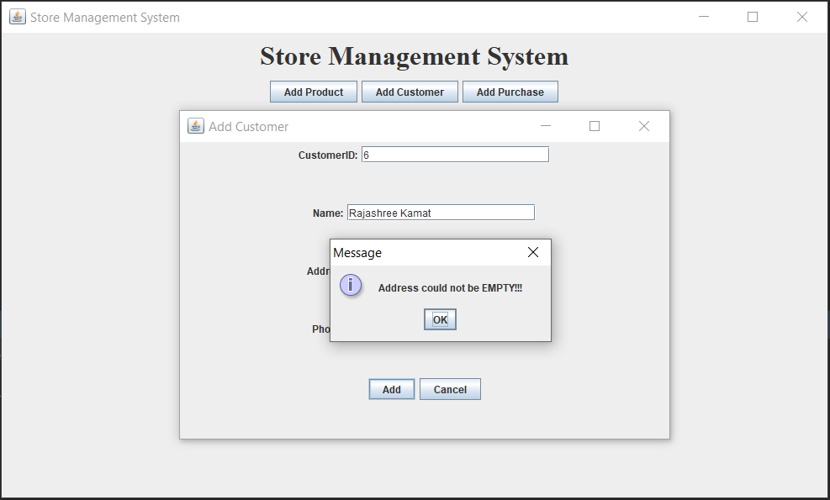

UI windows:

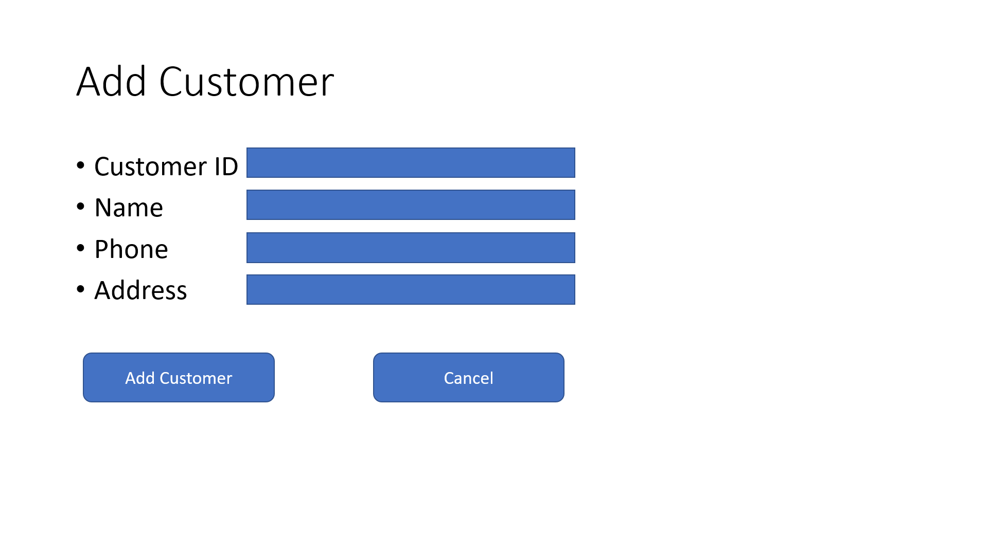

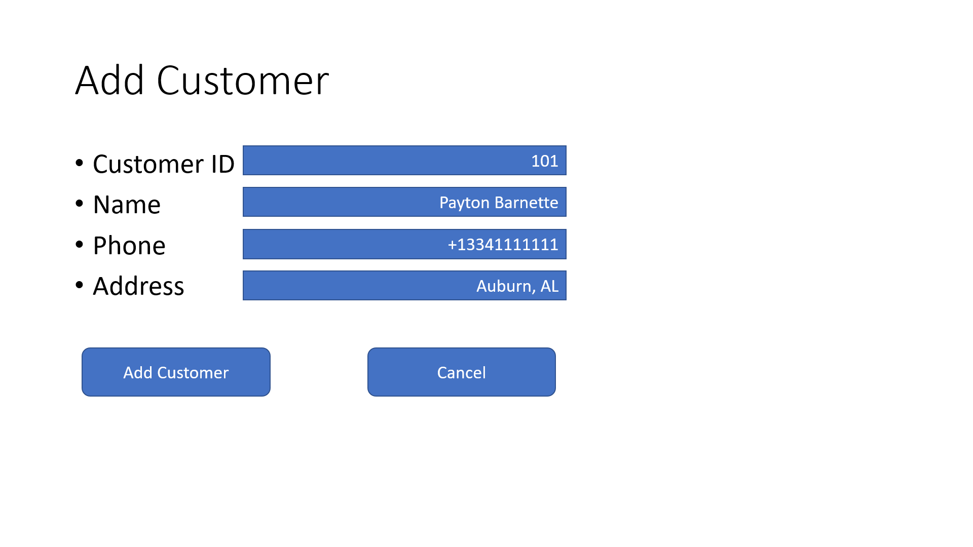

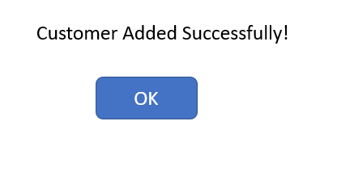

SQL Create query:

CREATE TABLE "Customers" (

"CustomerID" INTEGER NOT NULL,

"Name" TEXT DEFAULT 'Guest',

"Phone" TEXT DEFAULT '334-111-1111',

"Address" TEXT DEFAULT 'Auburn, AL',

PRIMARY KEY("CustomerID")

)

SQL Insert query:

INSERT INTO Customers (CustomerID, Name, Phone, Address) VALUES

(1, ‘Tung Nyugen’, 3341111111, ‘Auburn,AL’),

(2, ‘Phong Vu’, 3341234567, ‘Auburn, AL’),

(3, ‘Payton Barnette’, 3343991193, ‘Tallassee, AL’),

(4, ‘Ishita Joshi’, 3344009514, ‘Auburn, AL’),

(5, ‘Kevin Sam’, 3341352468, ‘Auburn, AL’);

**Story 3:**

As a user, I want to add a purchase from a customer into the system.

Common use case:

1. Purchase added successfully

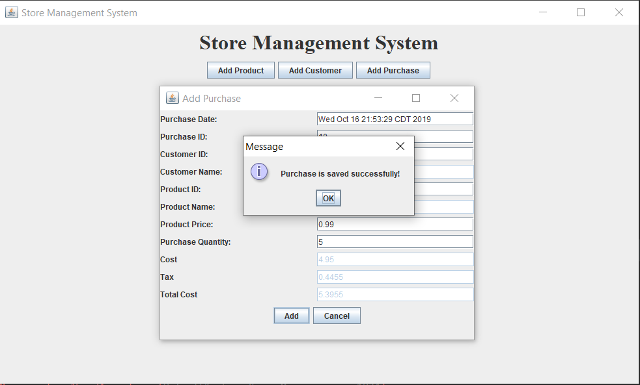

Exception case:

1. PurchaseID cannot be empty.

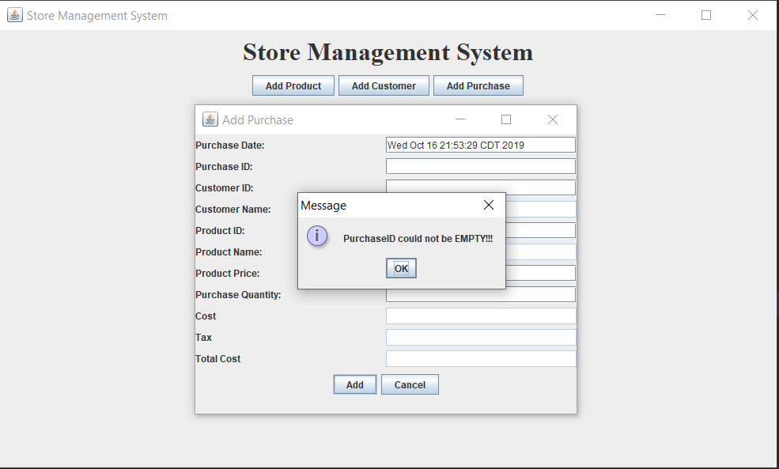

1. PurchaseID is not a number.

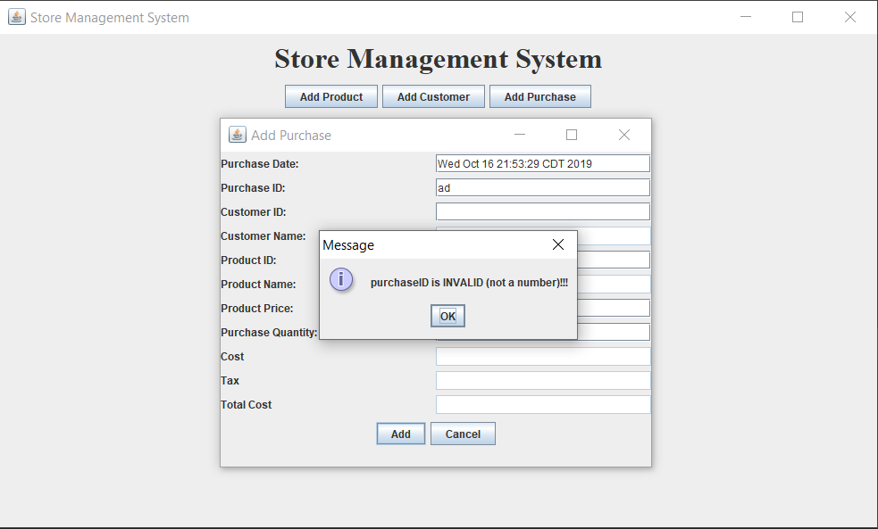

1. CustomerID cannot be empty.

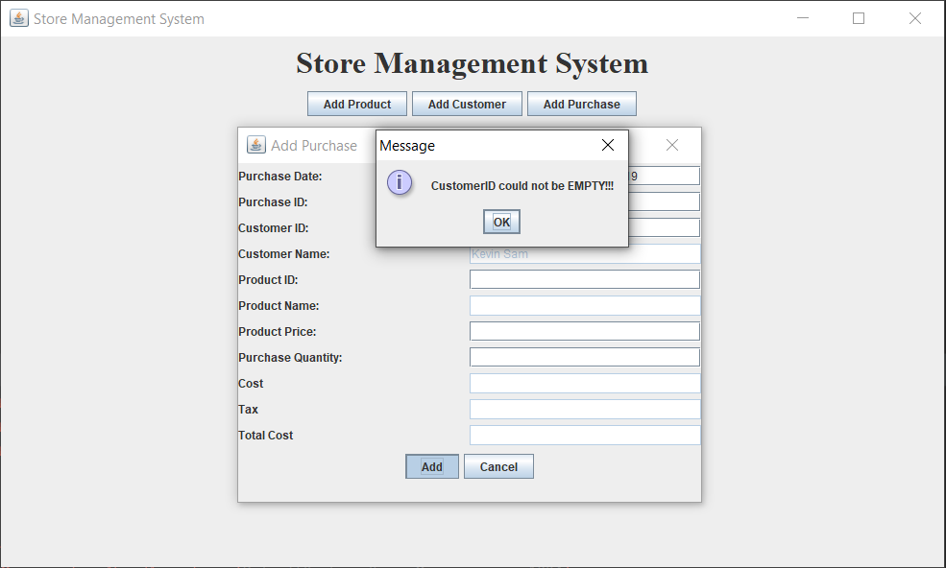

1. ProductID cannot be empty.

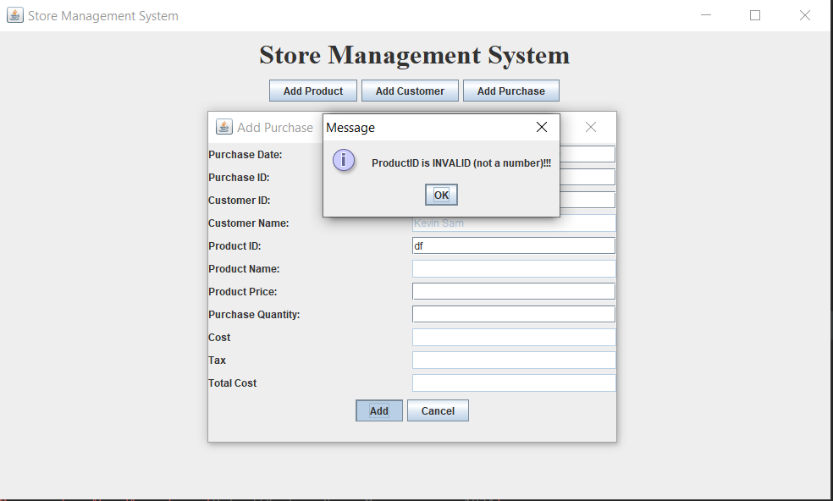

1. Quantity cannot be empty/ zero.

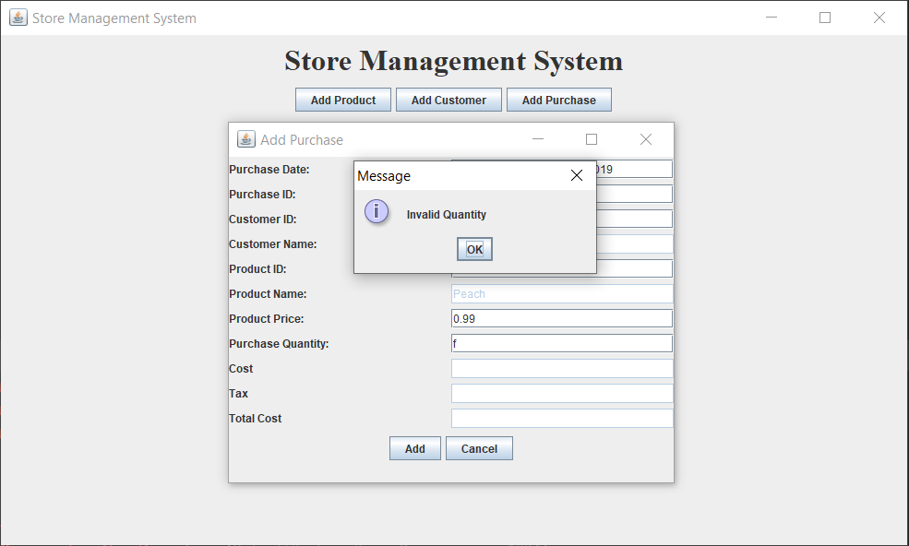

UI windows:

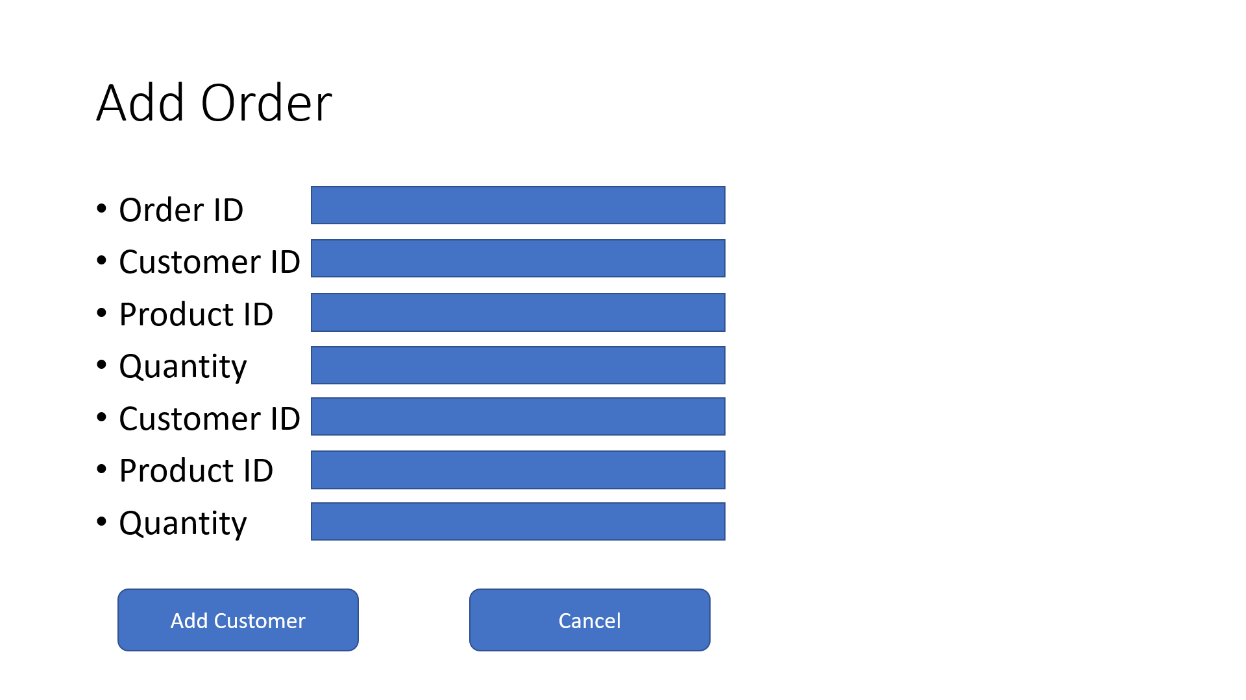

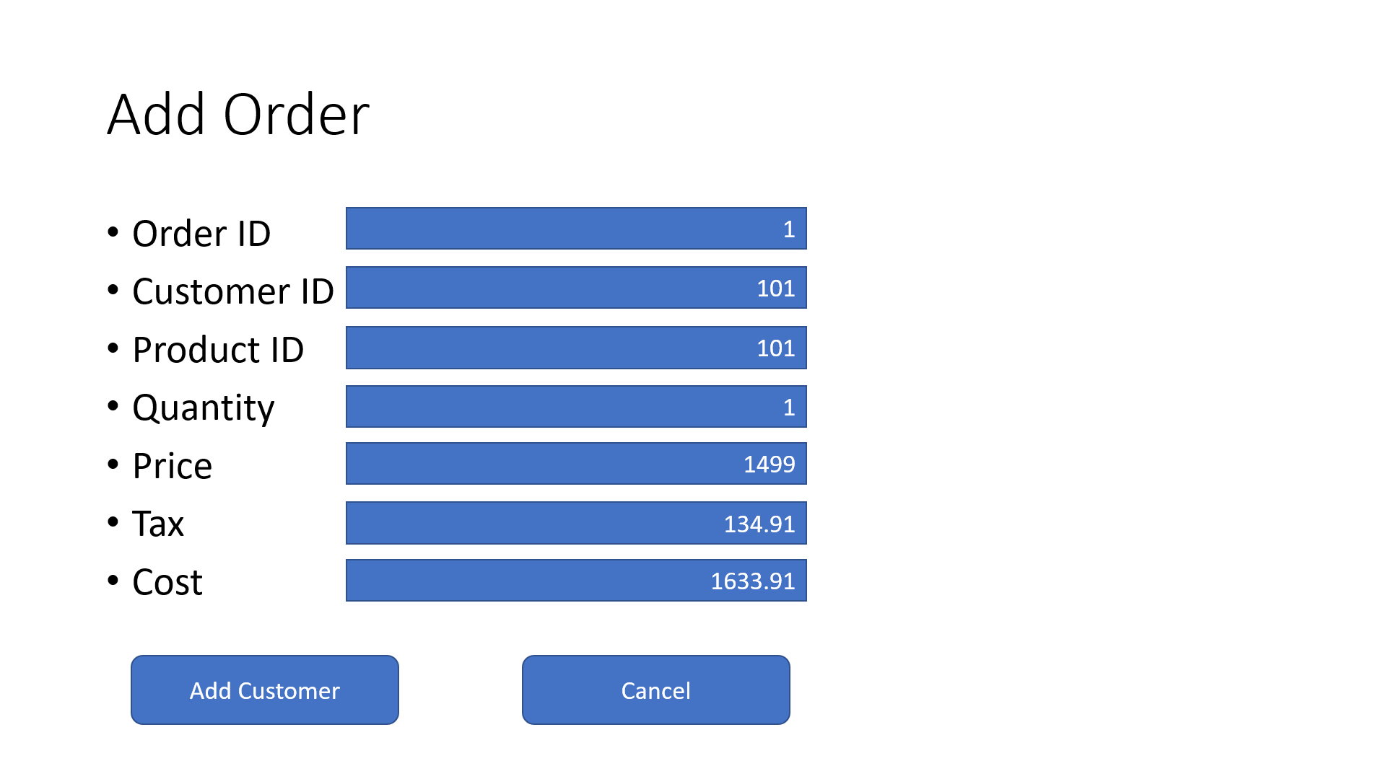



SQL Create query:

CREATE TABLE "Purchase" (

"PurchaseID" INTEGER NOT NULL PRIMARY KEY AUTOINCREMENT,

"CustomerID" INTEGER NOT NULL,

"ProductID" INTEGER NOT NULL,

"Price" REAL,

"Quantity" REAL DEFAULT 1,

"TaxTotal" REAL,

"CostTotal" REAL,

FOREIGN KEY("CustomerID") REFERENCES "Customers"("CustomerID")

)

SQL Insert query:

INSERT INTO Purchases (PurchaseID, CustomerID, ProductID, Price, Quantity, TaxTotal, CostTotal) VALUES

(1, 1, 1, 0.99, 5, 0.44, 5.39),

(2, 2, 2, 0.99, 10, 0.89, 10.79),

(3, 3, 3, 0.99, 5, 0.44, 5.39),

(4, 4, 4, 0.49, 12, 0.52, 6.40),

(5, 5, 5, 2.49, 3, 0.67, 8.14),

(6, 1, 2, 0.99, 3, 0.26, 3.23),

(7, 2, 3, 0.99, 4, 0.35, 4.31),

(8, 3, 4, 0.49, 6, 0.26, 3.20),

(9, 4, 5, 2.49, 2, 0.44, 5.42),

(10, 1, 3, 0.99, 12, 1.06, 12.94);